Detailed Description of Project

# Introduction

Our project is a scientifically accurate graphical simulation of a star as a function of mass and time. The user controls both of those quantities, and

# Data

In order to accomplish this, we use a set of star data acquired from a website called [EZ-Web](http://www.astro.wisc.edu/~townsend/static.php?ref=ez-web#Using_EZ-Web). EZ-Web data appears next to our code in a folder called “Stellar Database” and is in the form of .txt files. Those text files consist of tabulated data of the star’s life, with rows representing different points in time and column representing different quantities (if you really want to examine this further, we recommend taking a look at the files and importing one into an excel spreadsheet to see it properly). When run, our program takes one of those files, imports it in the form of a two-dimensional list, and that list is organized in a way that allows for easy access by the rest of the code, using associations to define each quantity.



Figure : The main body of our dataset initialization function.

These data lists are then interpolated into functions of time, which lets us use realistic data for the star at *any* point in time within the bounds of the data provided. To avoid odd behaviors when there were large jumps in time, the interpolation order of all of the functions is one, meaning that the interpolation is linear.

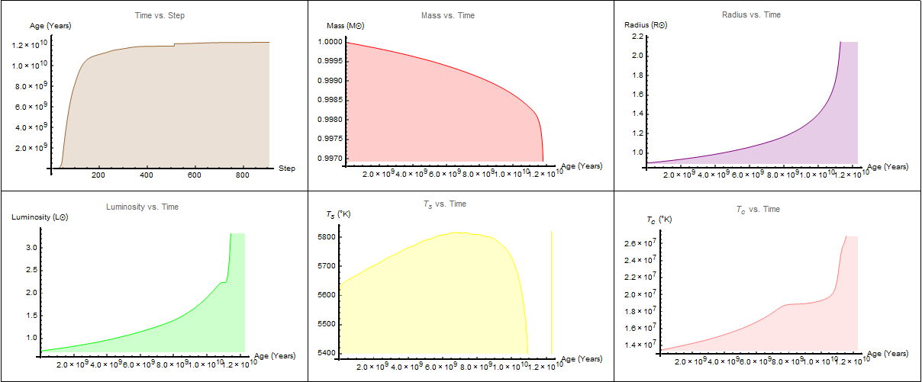

Figure : Some of the functions created using our interpolation methods, displayed in graph form at the end of our project. Because the point density of the database is so high, the interpolation appears to be nonlinear even though it is.

The exterior graphic shows the exterior of the star as a whole. The surface of the star changes color in response to its changing radius over the range of its maximum and minimum radii. We did not fully anticipate being able to make the star fade to white as it became a white dwarf (for 0.1 and 0.5 MSun stars) or show a planetary nebula at the end of the life of a 1 MSun star, but it was completed. Due to the wide range of sizes that a star can take, scaling functions had to be created to switch the PlotRange based on its current size, which will cause the star to sometimes look as if it has undergone major compression when it is simply a change of scale. Also included are a set of text readouts that give information about the mass, surface temperature, core temperature, radius, luminosity, and age at any point in the star’s life. Something else that was originally unanticipated but completed was a BarChart that expressed the elemental composition of the star by mass. Next, there is a core graphic that expresses the elemental composition of the star by radius. What was proposed was a single core graphic, whereas we ended up allowing the user to choose whether the core graphic was to be viewed on its own scale or on the scale of the star as a whole. The last graphic was an HR-diagram (Hertzsprung-Russell), which is a plot of luminosity vs surface temperature. This is widely used by astronomers to observe what stage the star is in its life. Our HR-diagram features a point representing the star which follows along a dashed path that represents its path from the start of the time frame to the end. The x-axis is reversed, and the y-axis is logarithmic to fit the formatting of HR-diagrams today.

We did not originally propose to include a user interface, but this has also been incorporated. It consists of a home screen that allows for the user to pick the starting mass. This then leads to a window where the user is able to set a lower and upper bound on the region of the star’s life being viewed. This information is then used to initialize the star and the simulation. It is important to note that many quantities are expressed as multiples of the sun’s properties. Throughout the entirety of our project, we have worked with Dr. Carini concerning the Astronomical/Astrophysical aspects of our project. We offered our project as a demonstration for future Astronomy classes that he would teach (granted that it accomplished what is supposed to), and he has recently (Reese, insert his decision here).